1987-88 Muskegon Lumberjacks game program

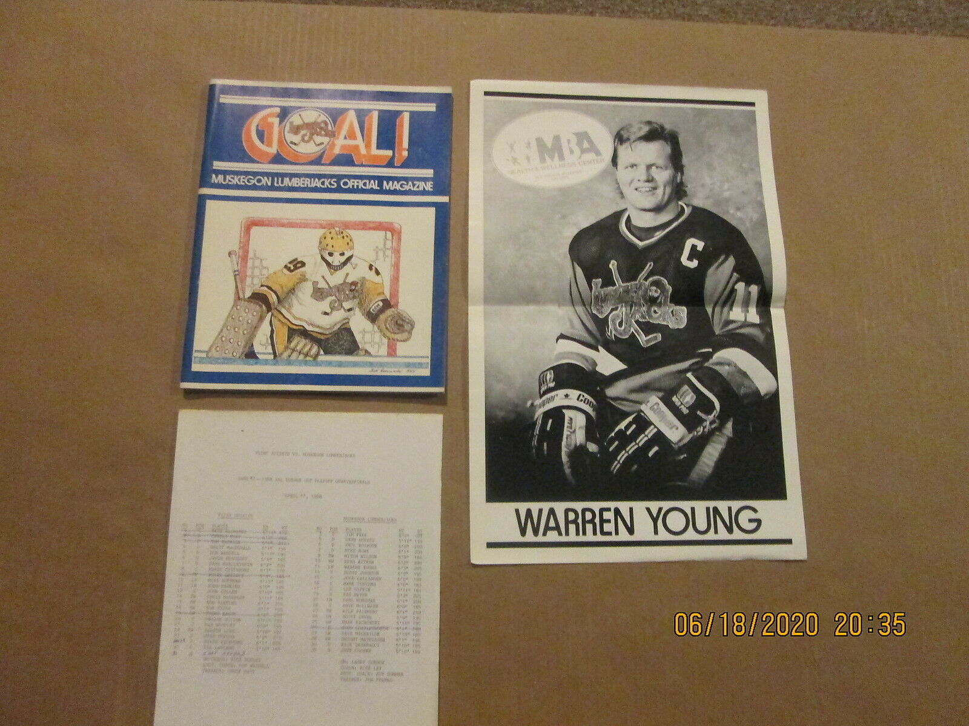

Magnified views of the program’s lineup insert

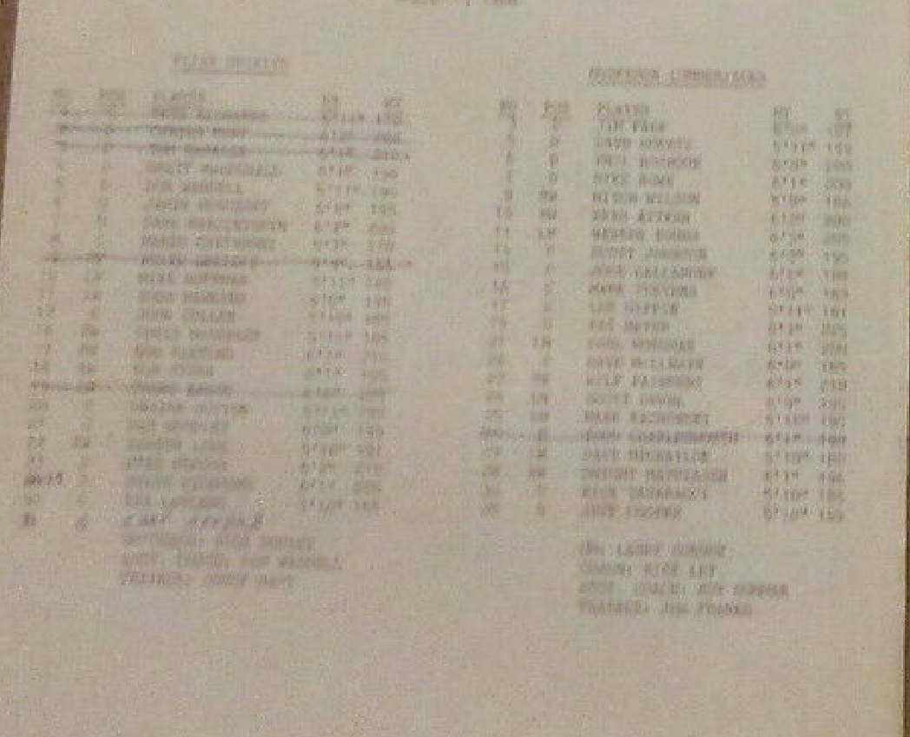

27 LW DAVE MICHAYLUK
29 RW DWIGHT MATHIASEN
31 G RICK TABARACCI
35 G JEFF COOPER

